**Table 1**

Summary of Results From Linear Mixed Effects Modeling of Experiment

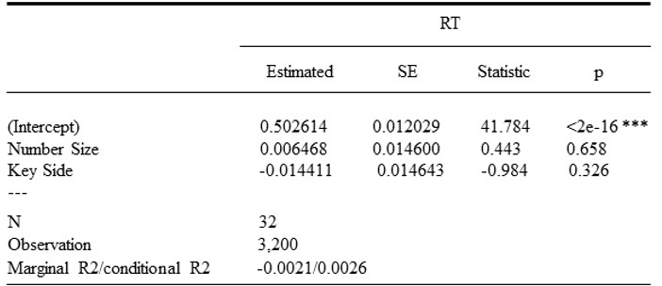

*Note: There was not a significant relationship among number size effect, Key Side and reaction time (RT).*

*\*p<.1. ***p<.01*

Proactive participants and individuals who cannot normally reflected on task stimuli had been excluded at the data cleaning process based on time frame between 150ms and 900ms. Besides, wrong answer given by participants are deleted as well. For instance, the right appearance of stimuli followed by left or space button press. The space response has been filtered out of concern with regard to its purpose of control variable. The mean average time of RT has been set as dependent variable while the Number Side, which divide the number 1 and 2 in category smaller than five and 8 and 9 in category more than five, and Key Side, left button and right button reaction matching the appearance of left side symbol and right side symbol respectively, are analyzed as two independent variables. The two-way ANOVA and linear mixed modeling analysis have been conducted based on 32 participants’ data (100 trials performed by each individual to gain the total 3200 reflection rows). Table 1 shows that the p-value of Number effect and Key Side are 0.65 and 0.32, respectively, under the 95% confidence interval, which may not significantly illustrate a relationship among number size effect, Key Side and reaction time. The value for both R Square and adjustive R Square are extremely low (0.0021 and 0.0026) that may question the coefficient of determination variables in linear regression model. F ratio in Table 2, 0.13 for Number Size and 0.97 for Key side toward RT, may illustrates a nonsignificant statistic either between Number Size effect and RT, or Key Side effect and RT. The p value for each variable is large than expected results that could not relate to dependent variable RT. However, the F ratio for Key Side is 0.96 which close to 1 may infer a potential tendency. In conclusion, the influence of the independent variables in the model on the dependent variable RT is not statistically significant, and the overall effect of the model is weak. Considering the data leaning processes which exclude a large number of data (nearly 12%) that may slightly change the outcome to possibly indicate a positive relationship between long/short RT and the present of left/right side stimuli, although the participants may not be informed well at the beginning and lead to data omission or data error in some degree. It may be necessary to rearrange the construction of the model or take other possible confounding variables into concern in the future.

Table 2

Summary of Results From ANOVA Analysis

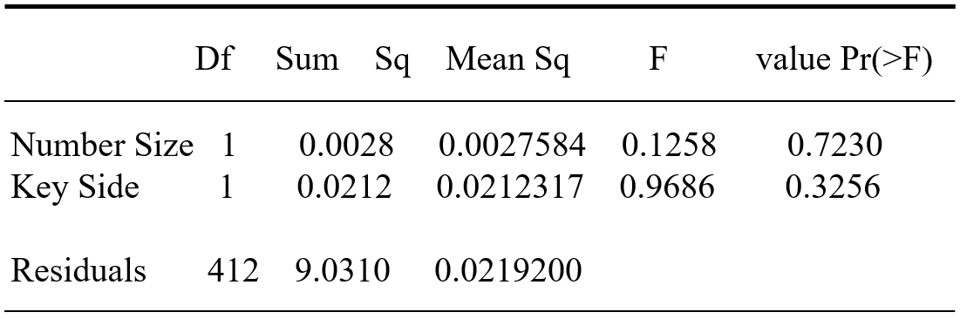

Even though a variable with a large p-value is not statistically significant, it could simply be the result of sampling error and a modeler might wish to keep it